Add cover Add comment

**ICT Rejection Block**

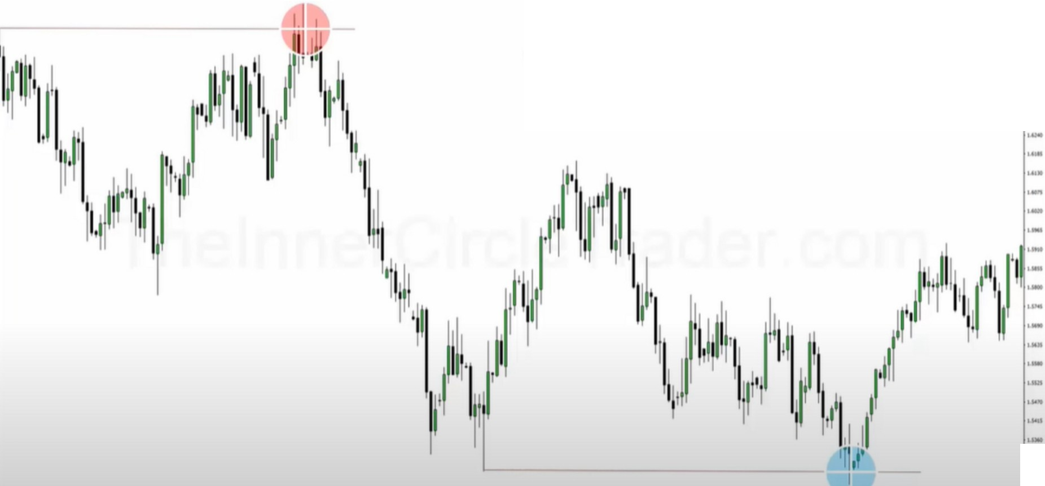

**What Do You See In This Chart At Major Highs & Lows?**

-- ,.,.., "..,., • ..,.,, •-•• **u..a, ..,_ •"4•1 U"-4- D"-4•• 11"4••** •-•• ,.._., •••• '"'"*' **"a.a, o,,ao,** •-•• **_.. ...a--,..,.,, u.. a, o..a,** ,.,._, ... - • =-- ,- -,.=.'."""'_,.,!.':.

·-

**--.-1.11.......-.....** ,_

--



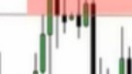l1· ll l' t111\, I ;

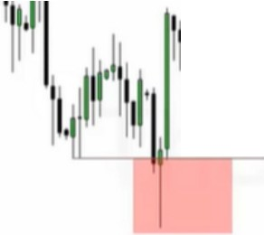

1

•

|  |  |  |  |  |
| --- | --- | --- | --- | --- |
| t  I  **·1 11** | /111,r1  II  III  ,, | '!1' | .,, | ]  q·1::  11 **11** ::  :: |
| I' j |  | ,, |  | :: |

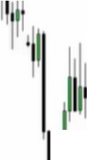1c---c- , ...... .-- .,-.IM •-•,. ••, - - - -, - **h-• -h- h- --** •**,**- -,- -, **h**,**m**• **,**

I,

·-

- -..,.-·-

 

Turtle soups, the classic types of distribution and accumulation

Everytime a new high or low is formed we anticipate some sort of rejection, that is the first anticipatory price skill set you should be working on because it is the hardest

Tonight he will teach a different approach to accumulation or distribution

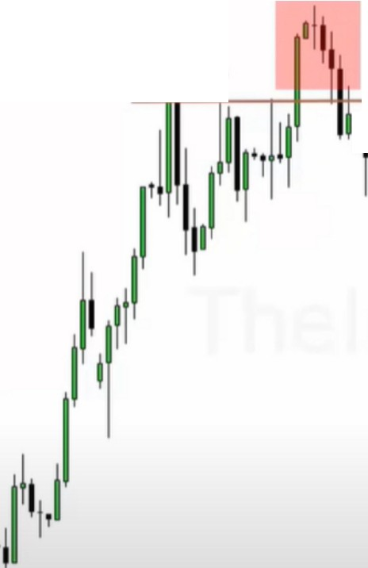

**Reinforcing Orderblock Theory**

,Reiect on BlocK]

**Bearish Run On Buy Side Liquidity** (Turtle Soup Sell)

Stops

I

l,1,,,I.ii

1··11,r'I

lr',111,.

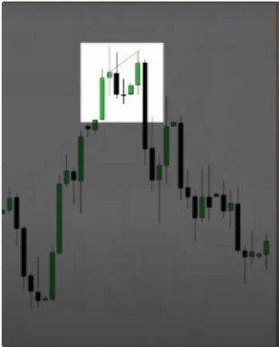

-.' ,..

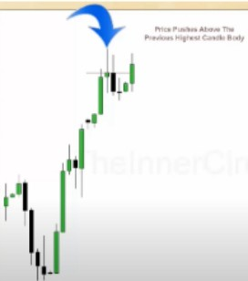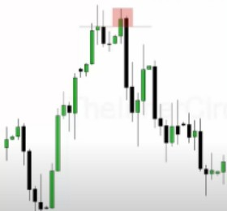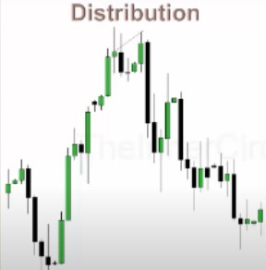

This is when we move into a PD array, in this case Premium array. Its also a bull flag Price does not need to make a higher high to make a failure swing

All you need to know about price action is basically the open high low and close, and if you follow the swing highs and lows, and you chart the open high low and close and deal specificaly with the open and closes youll be able to figure out what distribution and accumulation takes place at these turning points

Were not really focusing on the wicks, the wicks highlight the idea of the pattern forming

We look for the highest close or open at the swing high that forms, it doesnt matter if the highest candle is bullish or bearish closed

We see the wick as a bearish orderblock

This is one of the few times where ICT uses selling on a stop order as an entry pattern, you could also immediately enter on the close in this case, or wait for it to trade trough it a bit, or like ICT does a sell stop where it trades above the close and you place a sell stop at the close to sell it on when it goes back down again

It can form over multiple candles, its not limited to 1 candle



**Rejection Block Rejection Block**



RojcctionBlock

**111t**

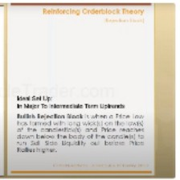

Re].-c:tion Block

I

-•

11

11

**111t**

11,1,I

ijl

fi ,111

1 1

11 1,1

On a bullish rejection block its the opposite, so we take the lowest open (incase of a bullish candle) and the lowest wick and that is in theory our bullish orderblock, the wick.

**The key is it has to be a swing low/high that has a wick or wicks**

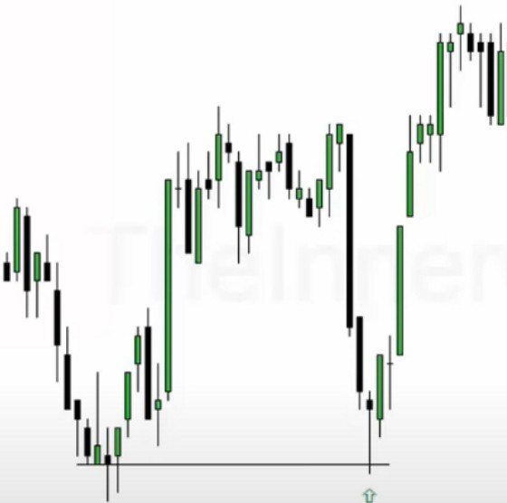

**Rejec ion Block**

**Reinforcing Orderblock Theory**

:i;,eJ ction Block,

Ideal Set Up:

In Major To Intermediate Term Uptrends

**Bullish Rejection Block** is when a Price Low has formed with long wick(s) on the low(s) of the candlestick(s) and Price reaches down below the body of the candle(s) to run Sell Side Liquidity out before Price Rallies higher.

We dont always demand that price goes below the wicks, its really the bodies of the candles, thats the closest to institution levels youll get

If the old low/high has a lot of long wicks then you'll be looking for a rejection block instead of a sweep of the wicks it will be a sweep of the bodies

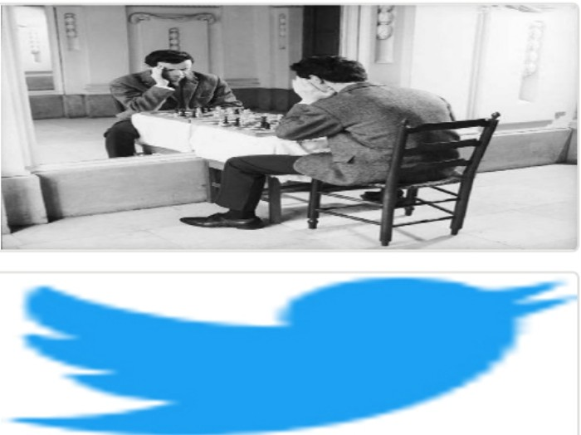Arjo I Twitter, lnstagram I Linktree

Linktree. Make your link do more. https://t.co/HhmmTN1fUI

JavaScript is not available.

***"!I*** https://twitter.com/arjoio